Hi Andy,

Ursula emailed you a few days ago about a couple of things and I just wanted to follow-up with a little more explanation. The T2D study we’ve been working on is a little bit of a unique situation because even though the original study with 80 patients ended several years ago, we’re still running additional analyses on that data. However, since then, we’ve rescanned about 30 of those patients for follow-ups. Normally this wouldn’t be a problem, but when I was doing the contouring for the follow-ups, I realized that the data was drastically different from the original scans because their _trab.gobj files were never corrected. After consulting with Dr. Long and Dr. Kazakia, we agreed I would re-contour the baselines. We’ve been juggling this with the need for analyses with the old original contours by using the old versions of the scans (e.g. _CRTXFILL.AIM;4) when necessary and the new versions (e.g. _CRTXFILL.AIM;6) otherwise. However, since we switched over to the new disk, it seems that all of the original versions that we were working with are gone. Is it possible these original .AIM and .GOBJ files are on the tape?

Additionally, we have a few folders with FE files that we asked Dr. Kazakia to submit with her new QB3 cluster access. Several weeks have passed and we don’t see any output. She didn’t notice any error message when she submitted it, so we’re wondering if you have any insight on what may have gone wrong? Additionally, if you would be able to submit them successfully in her absence, we would greatly appreciate it. Here are the file paths.

/data/polyphemus/projects/Long_T1D/

/data/polyphemus/projects/Long_T1D/

/data/polyphemus/projects/Long_T1D/

Obviously this isn’t something you need to take care of while you’re on vacation! But I’m leaving the office until the end of August (I’ll be available remotely) so I wanted to make sure I sent this. Enjoy Europe!

Best,

Courtney

Hi Ursula,

I’ve attached the results from the Laminar Analysis TMD output for the T2D scans. I’m still working on Baseline Mapping (waiting on a response from Julio about converting the files back into .AIMs) and I will continue to do it remotely next week! Melis and I got the Regional Analysis output for the T1D study and I will have results for the original T2D baseline Distal scans shortly (we have copies of those original _CRTXFILL.AIM files so we can proceed without worrying about not having access to the original scans on VMS). I’ve emailed Andy about the FEA/the original scans so hopefully he will be able to work something out when he gets back!

Hi Galateia,

I wanted to update you on where we are with everything before I head out!

Gastric Bypass:

-The GB Skeletonization files and results are all in the

-The Baseline Mapping process is stalled as I am waiting on confirmation for Julio that the transformation results I’ve gotten so far look okay and I also need any script he may have to convert the .hdr files back into .AIM files so I can put it back into the Xct2 and convert them to the appropriate .gobj files. My thought process on the Baseline Mapping pipeline has been this:

-find transformation matrix from grayscale BL .AIM to grayscale FU .AIM

-use that transformation matrix to transform the BL _trab.gobj (let’s call it BL) to a projected FU _trab.gobj (let’s call it FU*)

-now at this point I get a little confused and asked for some clarification from Julio: the SOP describes that I must convert FU* back into an .AIM file, and in IPL find the overlap of the FU* and the true FU. Then bring this union FU* back into the UNIX system and using the inverse of the transformation matrix, it is transformed into a union BL* file. The SOP ends here, but I think these union BL* and the union FU* trab files are what we will need put into Xct2 and run 48 on. I think I’m just a little unclear on whether I need to do the “union” step. Hopefully, Julio will get back to me so I’ll be able to finish this up in the next couple of weeks remotely!

T2D Matched

-The UD/D Laminar Analysis & TMD results are in the Laminar Analysis folder of the

- Again, the Baseline Mapping process is only part way done for these scans.

-I’ve emailed Andy to see if there is a reason we didn’t see any error output and I’ve asked him to submit the FE files from his account in the meantime. I’ve asked he do the same for the T1D files too!

T1D Original

-When Andy switched out the disk, we lost the original contours from 2010 before I corrected them. I’ve emailed him explaining the problem and hopefully he’ll be able to restore them from the tape. Otherwise, I will probably be able to recreate them by just running 19 & 47 & 48 over again without correcting in between. So the Laminar Analysis & TMD isn’t possible on these scans yet because we don’t have their original CRTXSEG.AIM files.

-We do, however, have copies of the original CRTXFILL.AIM files for all of the distal scans so I’ve run Regional Analysis on the distals (Ursula asked me to last week).

I think that’s everything! I hope you’re getting some sleep in when you can and enjoying the family time :)

Best,

Courtney

Hi Melis,

I’ve finished the Laminar Analysis and just updated the same files that we already have. I’ve renamed Karen’s old scripts in the Laminar Analysis folder and uploaded my version so there shouldn’t be any more hiccups (I say that knowing full well I’ve just jinxed it and it’s going to crash now haha). Also, can I ask a huge favor?? I totally forgot that I have a note and a onesie in the second drawer of the cubicle that I meant to leave in Galateia’s office. If you get the chance next week, could you get Olivia to open her office and you can just leave it on her desk? I would so appreciate it! Text me if you run into any problems next week and enjoy your time at home afterwards. Good luck on your final too (ew but it’s almost over).

Cheers,

Courtney

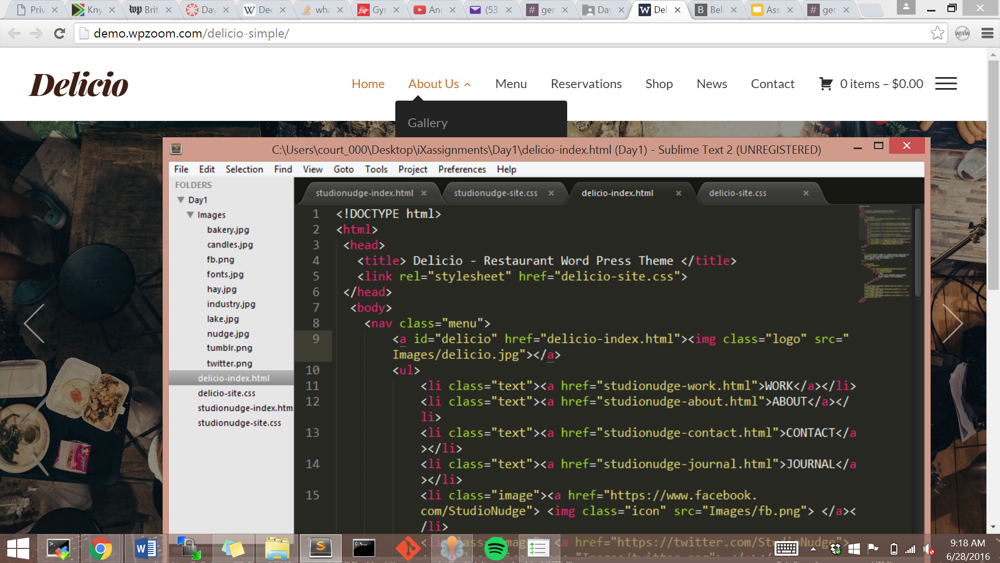

Websites:

<https://www.seedlipdrinks.com/>

Real simple design, but I particularly like the menu because the other menu items fade when hovering on an option. It’s a nice twist on the regular highlighting-the-hovered-item feature.

<https://studiokraftwerk.com/work>

I really like the overlapping boxes on with the projects and their description. I’ve been thinking about how I want to layout my research content on my own website and this might be a great option. I also love how the text fades in as you scroll further. i_Xperience’s website does this too and it looks really nice. Their more in-depth project description is engaging too because there is very little explanatory text and more pictures, trying to illustrate the user experience instead of just describing it.

<http://pharrellwilliams.com/>

I love all of these tiles! Each time you hover, the blob of color expands to reveal more text. Additionally, when you hover towards a certain direction of a screen, the screen view shifts subtly in that direction. I can see how to maybe get the blob thing to work on hover, but the screen view thing would have to be JavaScript and not really useful to me because I don’t think I will have a page with lots of tiled items.

<http://dismoielliot.fr/>

I really like the script animation thing for the title page. Gabe mentioned it would be do-able in Illustrator so I may consider doing that for my name on my home page and then I can figure out a more unobtrusive logo for the rest of my pages, if I even decide to use one at all.

Features:

